Donnelly, Des
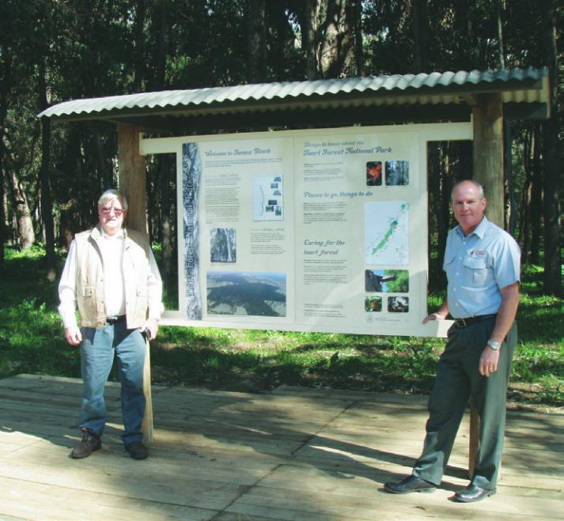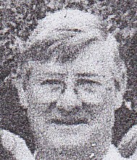
(Left) Des Donnelly, retired Forester and member of Lechenaultia Hoo Hoo Club, with national park sign in Ludlow.
At the Hoo-Hoo International Convention, held in Victoria, British Colombia, Canada, from September 9-13, 2011, the Leschenaultia Timber Industry Club (Hoo-Hoo Club 274) of Bunbury, took out the coveted Outstanding Club Activity Award for its ‘Tuart Discovery Trail’, a forest walk through unique regenerated tuart forest in the Ludlow Tuart Forest National Park.
The lesson to be learned from the Dwellingup fires is that hazard reduction burning in the forest is essential. That's the opinion of former forester and survivor Des Donnelly. Des was a 20 year old cadet in 1961 when fires swept through Dwellingup, destroying the town. Fifty years later, Des is again on the oval where townsfolk had sheltered that day. He points to the mill manager's house where he sat on the verandah waiting for the fires to pass. Growing up on a farm in Toodyay, Des knew how to use a chainsaw and drive a tractor. "Fire control in those days was hard work and hand tools." "The first two fires we managed to control but they started to get too big and we had to use machinery." "Spade, rake trails and pack sprays were the order of the day." Late in the Saturday afternoon, Des was paired with Jack Dearle, an experienced forester from Grimwade, to go round to houses to tell people to leave and head down to the oval. From interview by Sharon Kennedy, ABC South West WA 2011.
Des Donnelly was a forest cadet 1959-60 and worked in numerous places including Dwellingup, Gnangara, Grimwade, Pemberton. Appointed forest guard 1961, worked in Grimwade, Walpole and Pemberton surveying with Bill Redwood and Manjimup Working Plans Office. Married in 1963. Worked in. Nannup, Collie, Harvey, Ludlow, Busselton in 1960s-70s. Promoted to Forester Kirup in 1973. Promoted to District Forester Utilization and transferred to Bunbury in 1975 after the retirement of Len Nicol. Resigned in 1996 and started his own saw milling business in Capel and established private softwood and hardwood plantations. Retired in 2006.

Des Donnelly Notes on
- Forestry field cadet schools
- His forestry career

- Below is a photo of the original Ludlow field officer apprentice forestry school building. This photo was taken from the publication “50 years of forestry.”
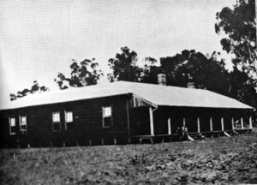
This building burnt down accidentally in 1973. The Busselton junior football club were using the building for a live in training weekend under the watchful care of Mike Adams. (Mikes father was the forest assistant in the Busselton office) The boys were called to breakfast and shortly afterwards smoke was seen billowing from the dormitory sleeping quarters.
Mike led all the boys to safety and despite the best efforts of the local Ludlow residents the old weatherboard building was consumed within minutes.
The building had not been used for field staff training for many years, possibly the early 1950’s.
When I commenced my career in forestry in 1959 the induction school was held in a collection of Nissan huts about 2 miles west of Dwellingup, the present school had not been built. The facility consisted of 2 huts for communal sleeping quarters, 1 hut as a lecture room, 1 as a kitchen and dining room. Ablutions were down near the creek with cold showers. This facility was completely destroyed in the Dwellingup fire in 1961.
Our group was one of the biggest intakes of students starting with 18 young men. Our initial OIC was Frank Podger. We were split into 2 groups; one group of 9 went to Pemberton under the direct supervision of John Meachem, the other group of 9 went to Gleneagle under the care of Steve Quain.
Each group spent 6 weeks each winter at Gnangara or Grimwade to assist with planting pines.
For the first 6 months of 1960 the Pemberton group returned to Dwellingup and the Gleneagle group went to Pemberton.
The new school in Dwellingup was completed in mid 1960 and the two groups came together for concentrated theory and field skill development. Our group were the first students to move into the new Dwellingup School.
We completed a 6-month intensive training course under the guidance of John Sclater. These buildings were saved from the ravages of the 1961 fires.
The attrition rate for the 1959 intake was unacceptable with only 5 of the original 18 trainees completing the course.
Two of the five graduates, John Patterson and Kurt Haunold, resigned during the following year. John joined Elders as a stockman and Kurt resigned to take up a management position with the Beatty park swimming pool.
Only 3 of the group worked out their careers with the WA Forests Department, ie Des Donnelly, Gerry Van Didden, and Bevan Foster.
Due to the difficulty retaining students the department employed skilled overseers, gang members and sawmill workers with particular knowledge and experience to fill the demand for field staff. Conservator Harris also recruited a number of trained foresters from Africa to fill senior roles in the forests department.
Promotion for Cadets depended on passing a forest guard bar exam within 3 years of completing the cadetship. Further promotion was also dependant on demonstrated ability to perform the many tasks required of field staff foresters. Once past the bar, promotion was dependant on passing written exams to qualify for promotion to the next level. Promotion was slow and depended on positions becoming vacant and then successful application.
Mature aged field staff employed, as forest guards above the bar were also required to pass promotional exams to progress through the field staff range. The system ensured a high level of forestry knowledge and performance, resulting in a very competitive, dedicated and competent field staff.
Unfortunately the training of field foresters was handed over to the TAFE system and promotional exams abandoned resulting in the totally dysfunctional system in place today.
Des Donnelly. 7th September 2013.

- Here are some notes on my forestry career.
Left Northam high school June 1956 aged 16 and began work for Industrial Extracts as junior clerk. This part of the timber industry involved the harvesting of wandoo logs, reducing them to chips and extracting the tannins.
The plant shut down for a short period in 1958 due to a mini recession. I was accepted as a forestry field cadet in Jan 1959.
Started work as a forest guard in 1961 after completing the 2-year cadetship straight after the Dwellingup fire.
Transfers were numerous as I was shifted around to gain experience.
Places I worked included Dwellingup, Gnangara, Grimwade, Pemberton, as a field cadet.
Grimwade. Softwood plantation establishment, management and utilisation.
Walpole and Pemberton surveying with Bill Redwood.
Manjimup working plans office,
Judy and I were married in 1963. Judy had graduated as a registered nurse and worked in each of the towns we lived in. Nannup, Collie, Harvey, Ludlow, Busselton, I focused on the softwood and hardwood utilisation side of the industry. During this time we raised a family of 3 girls.
I was promoted to district forester utilization and transferred to Bunbury in 1975 to concentrate on softwood milling and the promotion of softwood into the building trades. My first task was to build and operate the 1st high temperature softwood kiln in WA and to produce commercial quantities of visually graded structural softwood from the 6 departmental sawmills.
After the presentation of countless training and information sessions across industry in WA, softwood was accepted as a viable alternative to WA hardwood as a structural building material.
Promoted to Chief utilisations officer after the retirement of Len Nicol.
Introduced and developed a pole Inspection service for power poles in WA. Successfully introduced the use of softwood power poles into WA. Developed a feature measurement system for consistent hardwood log grading. Involved in the research into drying and utilisation of small diam regrowth Jarrah logs.
Resigned in 1996 and started my own saw milling business in Capel and established private softwood and hardwood plantations. Retired in 2006.
Now watching the slow death of forestry in WA. Particularly concerned for the future of the softwood plantation industry.
Des Donnelly. 19th September 2013.

